**VeriFactAI Complete Program Flow**

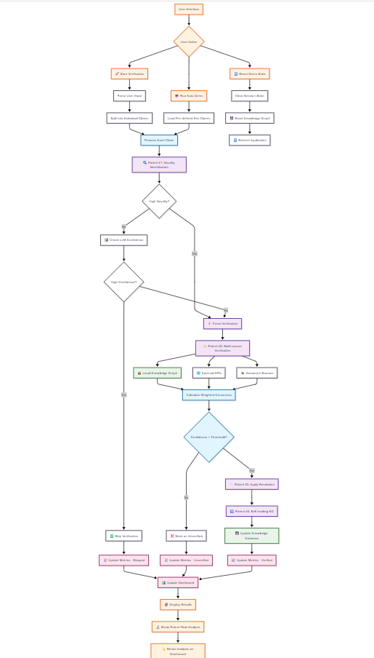

**Detailed Component Flow**

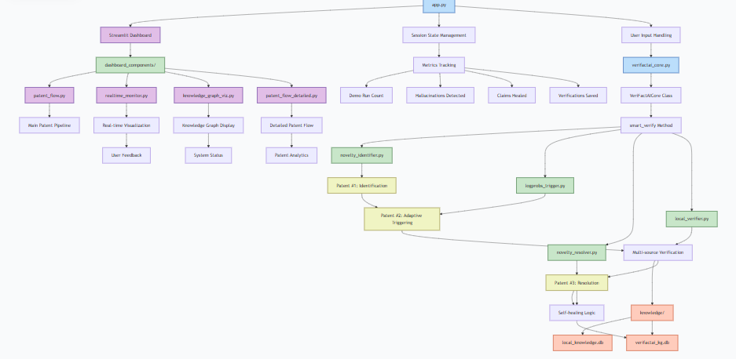

**Patent Value Chain Flow**

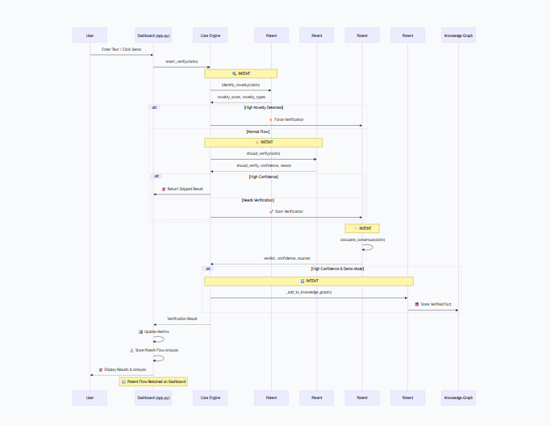

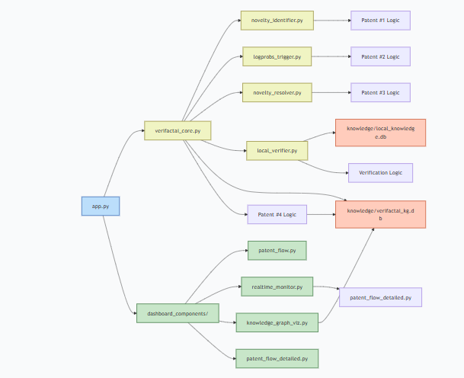

**Key Flow Points:**

1. **User Interaction** → Dashboard handles input
2. **Core Engine** → Orchestrates all patent logic
3. **Patent Chain** → Sequential execution of 4 patents
4. **Data Persistence** → Knowledge graph self-healing
5. **Visual Feedback** → Real-time dashboard updates
6. **Analysis Retention** → Patent flow stays visible

This flow demonstrates the complete value chain from user input to persistent knowledge improvement!